Use of Machine learning in mapping the casualties during conflict
Utilizing machine learning to track casualties during conflicts has become increasingly vital. Recent escalations of conflict in Palestine, coupled with heightened tensions along Lebanon's southern borders, have precipitated a series of confrontations within Lebanon. These events mark a notable departure from the established rules of engagement that both parties have largely adhered to since 2012. Observers note parallels between the current tensions and the 2006 conflict in Lebanon.

To systematically map and document casualties, data from online news agencies is being accessed via API links and then processed through machine learning algorithms. This restructuring facilitates the organization of data into a tabular format, with relevant fields such as full names, dates of death, causes of death, and localities extracted from the news. Machine learning serves primarily to discern messages and extract necessary information, which is then correlated with existing datasets and visually represented on maps.

This approach ensures that casualty information is available in real-time. Efforts are underway to extend this methodology to other types of news, such as forest fires and extreme weather conditions, for comprehensive monitoring and response.

This code extracts information from various sources mourning individuals from various organizations, storing it in a structured format. By organizing this data, we are feeding it into a machine learning model, which learns patterns from the extracted features (name, birth year, village, organization) to potentially classify or predict characteristics about future individuals mentioned in similar tweets, aiding in automated analysis or understanding of social dynamics.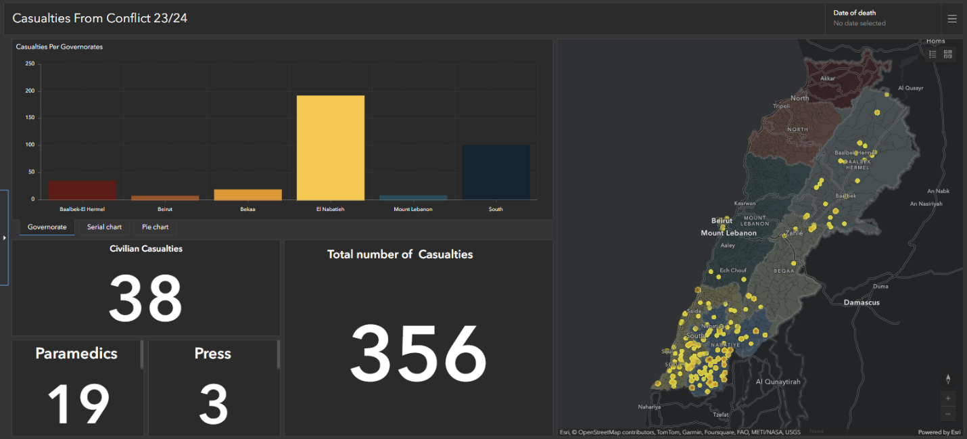
The dashboard provides a comprehensive visualization of the death incidents, offering insights into trends, distribution across villages, and temporal aspects, aiding decision-making and resource allocation.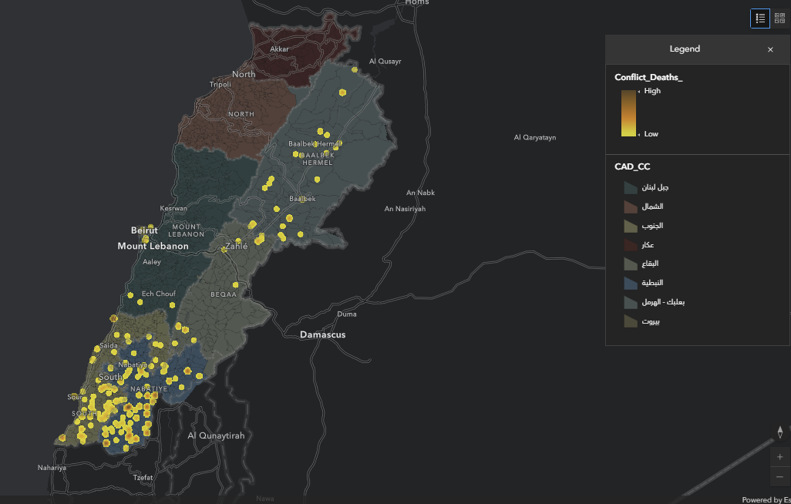
The heat map overlaid on the GIS map illustrates the intensity of deaths per village, providing a spatial perspective on the concentration of incidents and facilitating targeted interventions and support efforts in affected areas.
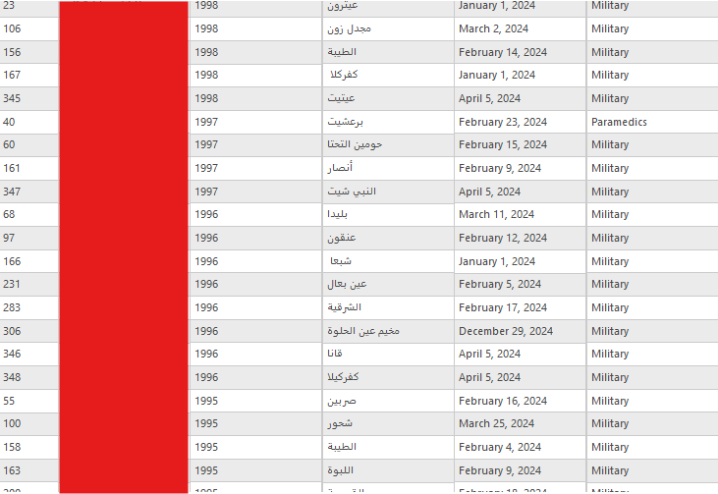
The GIS layer represents spatially distributed data of individuals' deaths, showcasing their names, villages, and dates of death, enabling spatial analysis and understanding of geographical patterns.

