Our Challenge

At British Red Cross, Our Systems & Operations team in the Learning & Organisation Development (L&OD) department are responsible for scheduling virtual learning sessions delivered via Zoom in our LMS (Cornerstone).

This was formerly achieved by the team receiving requests from a simple MS Form where largely textual free-format data was submitted, which often required clarification by phone or email before it could be manually entered into the LMS by the team

Our Solution

The BRC Automation Team enhanced the process to
- Capture primary information including which Event Name and how many occurrences were to be booked (MS Forms, Power Automate)
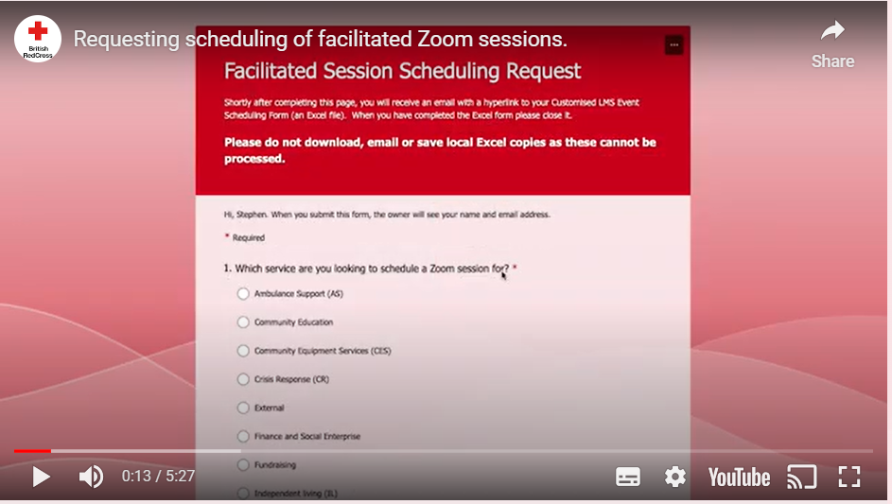

- Created bespoke booking forms for each request where Dates, Times and Trainer details could be recorded for each event occurrence (Power Automate using MS Excel Templates and Office Script)
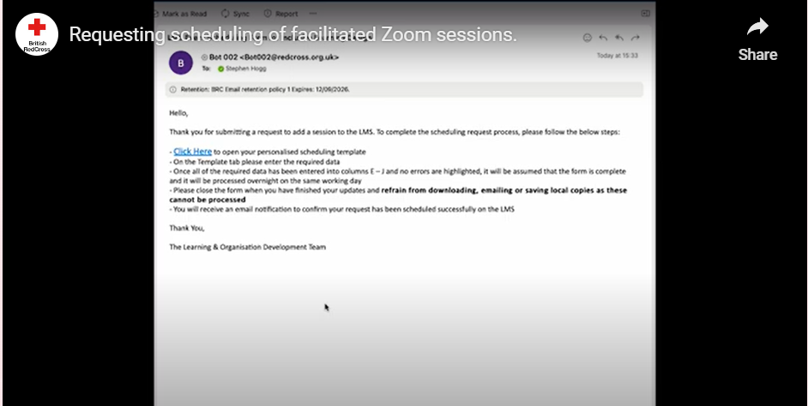
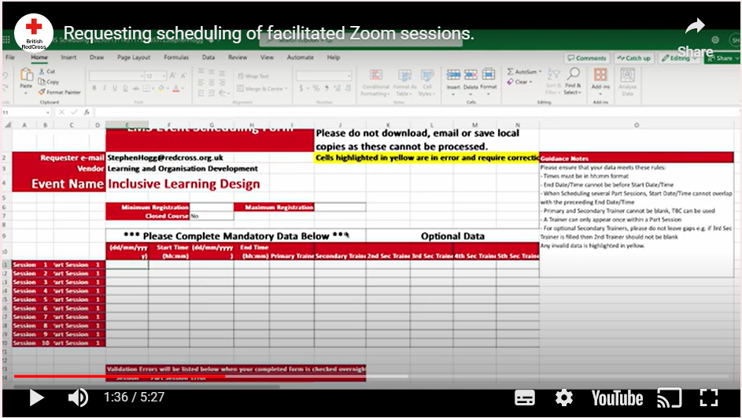

- Validated booking forms for accuracy and consistency, sending emails where errors were found or forms not promptly completed (Power Automate, Office Script)
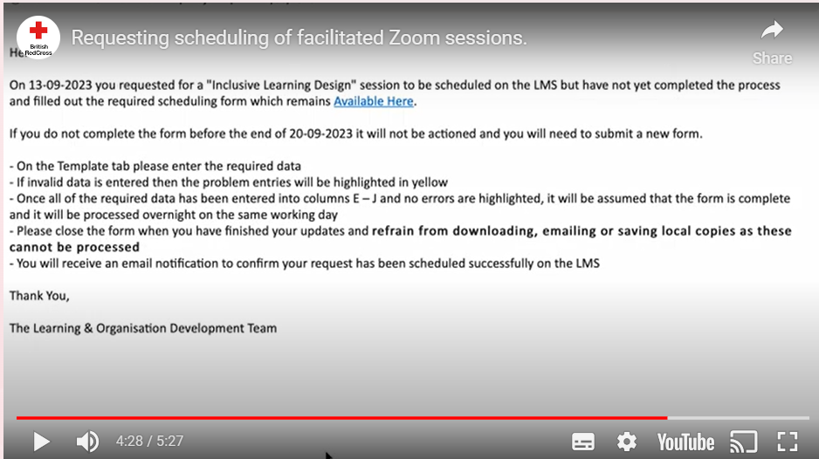
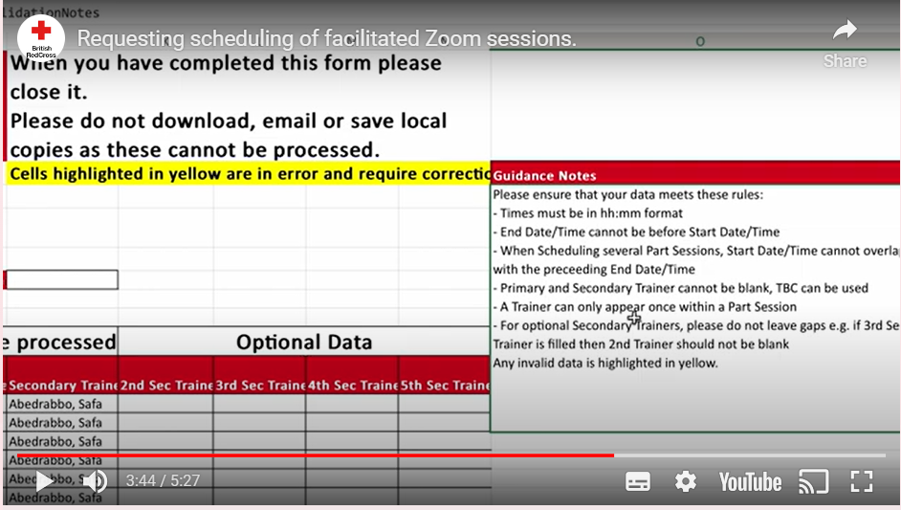

- Transposed data from completed booking forms into the LMS and sending emails to the requestor to confirm completion via RPA (Blue Prism)
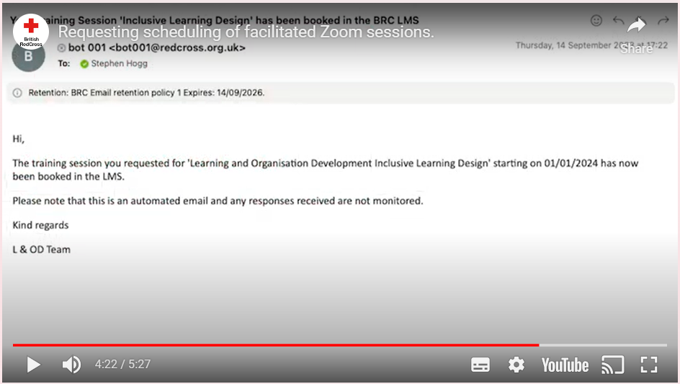

Ethical concerns
This process does not hold any data relating to Service Users or members of the public. The only Personal Identifiable Information (PII) involved are the forenames and surnames of BRC staff and volunteers in their capacity as Trainers on the sessions being scheduled. However, as with any automation we undertake, due diligence was completed in the following areas:
- Risk assessment: We were automating an existing process on behalf for the L&OD team and improving data accuracy and returning time to them. If the Blue Prism solution was not available, then the L&OD team would revert to the manual process. This automation was therefore deemed to be low risk.
- Data Privacy and Transparency:
  - All activities in Blue Prism automations are logged at the transaction level providing a completed audit trail. The level of required logging is determined by the Automation team depending on the process.
  - These logs are stored with BRC data centres and can only be accessed by the BRC Automation Team.
  - Any PII can be encrypted in the logs if required.
  - Our Data Privacy procedures used in Automations has been approved by the BRC Information Governance Team.
  - For this process it was decided not to store the Trainers’ PII data in the Blue Prism Logs.

The Benefits

The solution delivers an improved data flow and self-service user experience for learning teams across BRC who deliver facilitated learning sessions via Zoom, allowing them to schedule multiple occurrences of the same event in a single form, which are then updated in our LMS by our bots.

This improved accuracy and will return 3,700 hours p.a. to the team allowing them to focus on more added value tasks such as quality control, continuous system development and process improvements. This work was aligned with phase 5 of the L&OD review programme of Fit for the Future carried out in Q4 2022, aiming to ensure we have the right resources, systems and processes in place to make BRC a great place to work and to ensure that we can best meet the needs of people in crisis. ​

Confirming our automation model
LMS – Add Zoom Session has returned to the business team the largest number of hours of any automation to date. The process had many of the characteristics that are good candidates for automation namely
- ​Rules based​
- ​Manually intensive​
- ​Structured data​
- ​Frequent re-keying of data ​
- ​Low and known exceptions​
- ​High volume, low complexity​
- ​Prone to human error​
- Defined and documented process
This was our first automation that combined our proven Blue Prism solution with the Power Platform environment, specifically Power Automate, illustrating that a range of toolsets should be considered to provide the best user outcomes.

The Future
We are continuing to grow our Automation backlog and with our imminent migration to the Blue Prism Cloud environment we will be able to add to our toolset including
- Optical Character Recognition to extract business data from document images
- Process Interaction to facilitate the ‘Human in the Loop’ for approvals and corrections
- Leveraging AI Technologies which can seamlessly interact with Blue Prism Cloud

