A Case Study on the Remote Assessment in Disaster Affected Areas using mobile phone location data and AI

Yasuhiro SOSHINO^{(1),(2)}, Masahiro NEMOTO^{(1),(3)}, Akira MIYATA^{(1),(2)},
Yusuke KATO⁽⁴⁾, Kazuhisa Shibayama⁽⁴⁾

(1) Japanese Red Cross Kumamoto Hospital
(2) Disaster Management Research Institute, Japanese Red Cross College of Nursing
(3) Japanese Red Cross Hokkaido College of Nursing
(4) Agoop Corp.

1. Introduction
Japan is one of the most disaster-prone countries in the world. In the past disasters in Japan, such as the 2004 Niigata Prefecture Chuetsu Earthquake, the 2011 Great East Japan Earthquake, the 2016 Kumamoto Earthquake, and the Noto Peninsula Earthquake that occurred on New Year's Day 2024, the issues on the isolated areas and non-designated shelters have been frequently reported.
Firstly, in these disasters, road networks were frequently disrupted due to the landslides, collapses of tunnels, and the damages in the bridges. In result, a lot of people have become isolated due to the damage in the road networks.
Secondly, a lot people evacuated to the place where the local authorities had not designated as official shelters. While the evacuees need public assistance, the local authorities in the disaster affected areas had difficulties in recognizing, identifying and supporting such “Non-Designated Shelters” since they had not been officially designated as the public emergency shelters.
The issues on the isolated areas and the non-designated shelters are important if disasters occur in severe winter. In fact, according to the damage estimation for a Huge Earthquake along the Chishima and Japan Trench, 40,000 people may die from hypothermia due to power outages and lack of heating.
In this way, in the event of an earthquake or tsunami disaster during the mid-winter season, it is important to quickly collect information on isolated evacuees and the evacuees at non-designated shelters to provide emergency assistance.
Therefore, since 2018, the Japanese Red Cross and Agoop Corp. started the joint project on the application of mobile phone’s location data and AI in emergency relief operations. This case study reports the advanced AI application in the emergency response in Japan. The structure of this study is as follows; following the introduction, section two explains the AI application and Data issues in this project. Section three introduces the field test in the tsunami evacuation drill. The deployment of the AI in the 2024 Noto Peninsula Earthquake is presented in section four and section five discusses the impact, the challenges in this project. Section five also discusses the AI application model that links climate change mitigation and Disaster Risk Reduction. Finally, section six concludes this study.

2. Method
2.1 Background
The Japanese Red Cross’ Kumamoto hospital and Agoop, started discussions in 2018 about the application of people’s flow data in both emergencies and peacetime. Following this, in 2020 during Kumamoto Floods Response, people flow data (Fig.1.) provided by Agoop, supported the team of the hospital in their decision-making for a rapid response to the disaster. Based on these experiences, since 2022, the Disaster Management Research Institute, Japanese Red Cross College of Nursing started the collaboration with Agoop Corp. to utilize the people’s flow data and AI for the rapid assessment in emergency response.
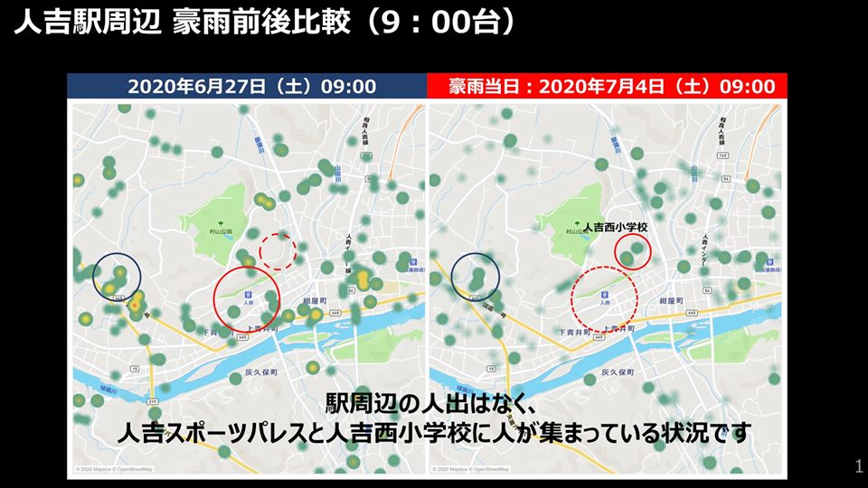
Fig.1. Heatmap before and after the 2020 Kumamoto Floods in Japan

2.2 AI and RPA Application
Two different solutions created by the Agoop are used in this project.
The first solution shows the movement of the smartphone users collected from smartphones GPS data. To protect the personal information of smartphone users, RPA is used for anonymizing the users.
The second solution displays the gathering of smartphone users using a heat map. This solution uses AI to detect unusual gatherings of people, such as undesignated evacuation shelters in emergencies.

2.2 DATA Issues
Agoop collects the location data from the other companies’ apps using Software Development Kit provided by Agoop with the consent of the users. As a result, Agoop collects people’s flow data from all the major telecommunication service providers in Japan without bias. To protect personal information, names and addresses are not collected from smartphones. Furthermore, location information itself is defined as personal information and is strictly managed. The point data of smartphone users within 100 meters around their homes is deleted using RPA, using information that has been anonymized.

3. A Field Test in Hokkaido, Japan
On 4 November 2022, the joint field test was conducted using the people’s flow data in a tsunami evacuation drill in Nemuro City of Hokkaido, Japan (Fig.2.). The two solutions were used to detect the unusual people’s gathering in a real time by using AI (Fig.3.) and (2) to review the evacuation behaviour after the tsunami evacuation drill (Fig.4.).
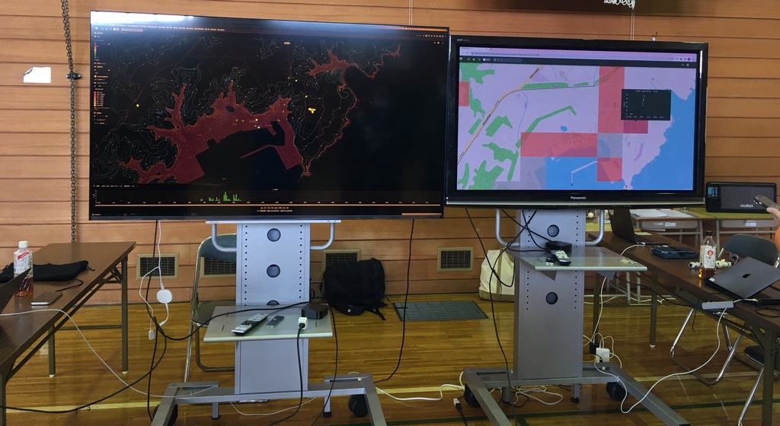
Fig.2. The Real-Time Evacuation Monitoring (Left) and Unusual Gathering Detection by AI(Right)
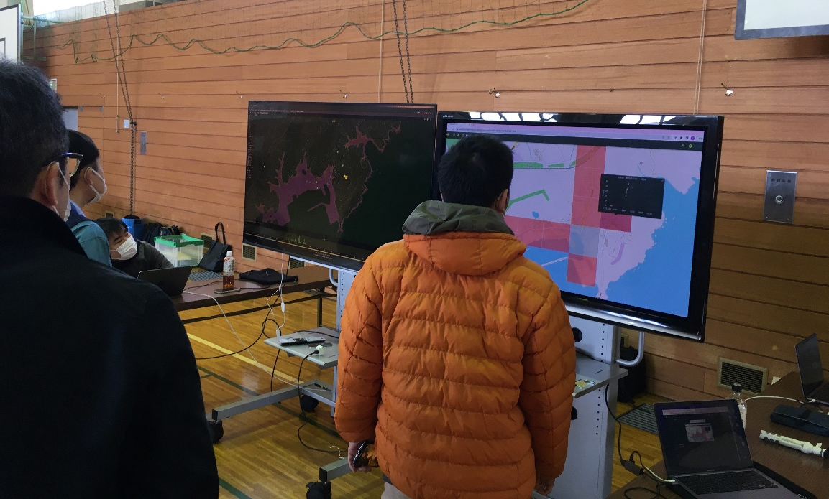
Fig.3. Real-Time Monitoring of the unusual people’s gathering by using AI
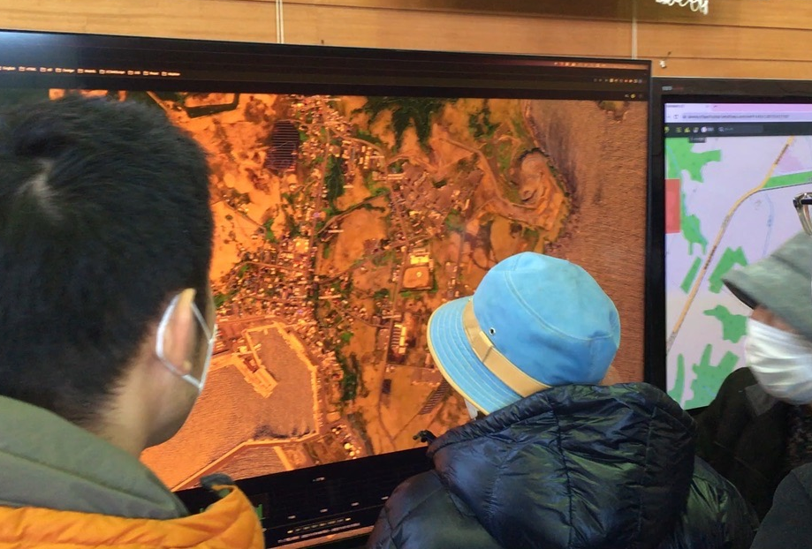
Fig.4. Participants reflect on their own evacuation actions by checking the people’s flow data

4. Deployment in the 2024 Noto Peninsula Earthquake Response
On January 1, 2024, a magnitude 7.6 earthquake occurred with its epicenter in the Noto region of Ishikawa Prefecture, Japan, killing more than 240 people and completely destroying 8,756 houses. A tsunami occurred along the coast, damaging a lot of houses and roads. Roads were cut off in various parts of the Noto Peninsula due to landslides and collapsed tunnels.
In the morning of 2 January, the authors started the rapid and remote assessment of the disaster affected areas by using the two solutions. The people’s flow data successfully identified the isolated areas (Fig.5.) by displaying the limited movement including the speed of the smartphone users. In addition, the heatmap by using AI detected the unusual people’s gathering in a lot of places in the disaster affected areas including the evacuees at the non-designated emergency shelters (Fig.6.).
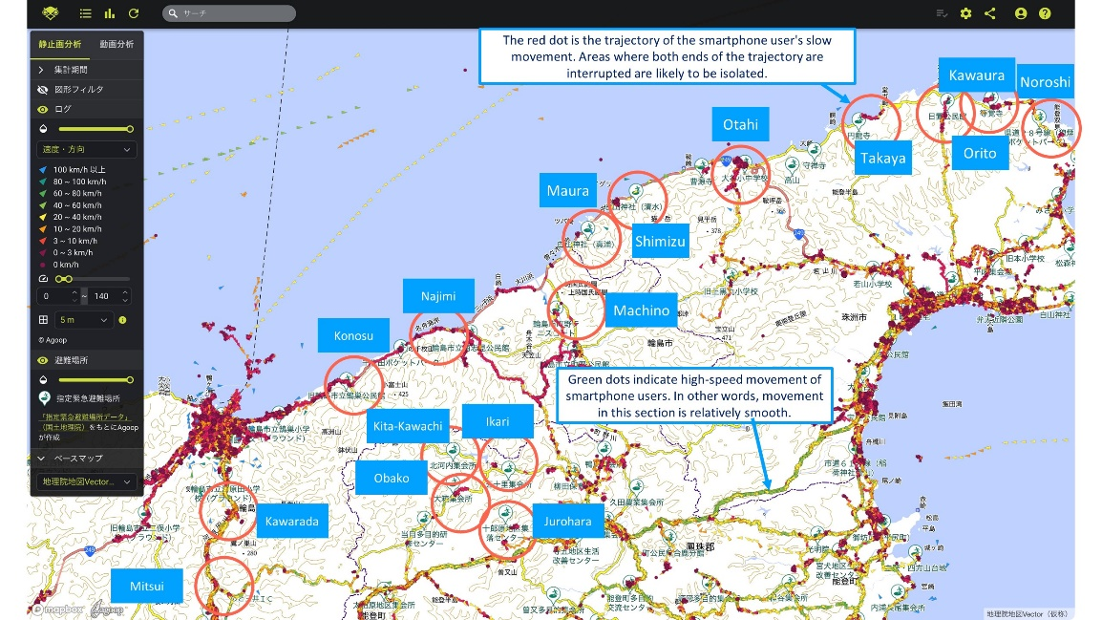
Fig.5. Identification of the Isolated Areas by using the People’s Flow Data

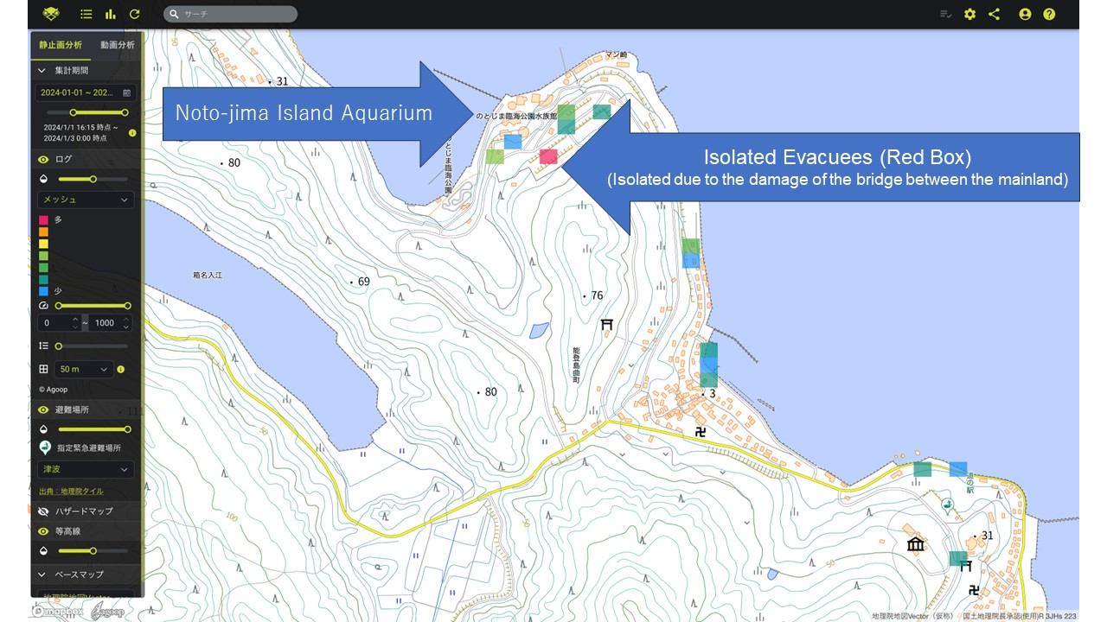
Fig.6. Detection of the Evacuees at the Non-Designated Shelter in an isolated island

5. Discussion
5.1 Impact
By analysing the people’s flow data, it has become possible to remotely assess a wide range of areas right after a disaster occurs, even before the surge teams arrive in the disaster affected areas. Specifically, from January 2nd to 4th, we conducted a remote survey of the entire Noto Peninsula (total area of 2,404 km²). The information collected was shared with other volunteer organizations through the JRCS headquarters. The information was also shared with local governments in the disaster-stricken areas through local JRCS medical coordinators. This shows that the Red Cross can function as an information hub for disaster response through the use of AI. In addition, the Ministry of Land, Infrastructure, Transport and Tourism introduced this application example in a guidebook for the use of human flow data published on 27 March 2024.

5.2 Challenges
Since this project was in its pilot phase, there was little mechanism in place to widely share analysis results regarding impassable roads, isolated areas, and non-designated shelters with relief agencies, including the Red Cross. Therefore, the authors are trying to build the information sharing mechanism by disseminating this relief method. In the future, the authors will work on disseminating this relief method by incorporating it into local government disaster prevention drills. In fact, on March 3, 2024, this method was demonstrated during a tsunami disaster drill in Kamaishi-City, Iwate Prefecture, an area affected by the 2011 Great East Japan Earthquake, and received high praise from local governments and relief workers. Furthermore, local governments in other regions have expressed their desire to collaborate with the Japanese Red Cross to introduce this method.

5.3 AI Application Model
In order to the immediate utilization of AI in emergencies response, it is important that AI is used in peacetime by the various stakeholders in the community. Therefore, the authors propose the daily application of AI to solve the social issues in the community in peacetime. This daily application of AI solution, which is effective in the rapid assessment in emergencies, improves the social resilience by preparing for emergencies in peacetime.
For example, the people’s flow data can be used in urban planning aimed at eliminating traffic congestion during normal times as Agoop does with a local authority of Hino Town, Shiga Prefecture in Japan. This effort contributes to mitigation in the climate change actions by reducing the greenhouse gas emission. Furthermore, the daily uses of AI-based solution by local authorities will also help build a society that is resilient to disasters. In this way, this model promotes synergy between climate change mitigation measures and disaster mitigation (adaptation measures) by utilizing AI as a common solution to social issues during normal times and issues during disasters.

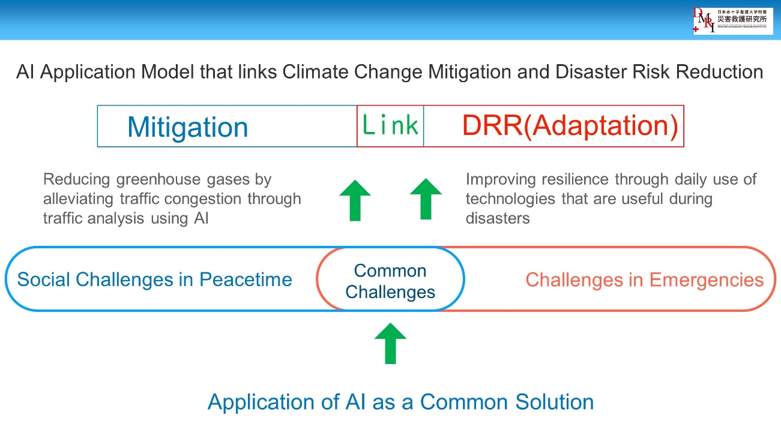
Fig.6. AI Application Model that Links Climate Change Mitigation and Disaster Risk Reduction

6. Conclusion
In this project, we explored the use of AI to understand evacuation situations during disasters. AI demonstrated its effectiveness in evacuation drills and in the actual earthquake relief that occurred in January of this year. Based on this, this research proposed a model that utilizes AI as a common solution to social issues both in normal times and during disasters.

